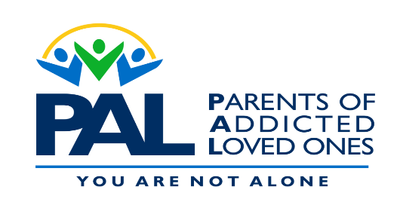
Indiana P A L Meetings
AVON | BEDFORD | CARMEL
Thursday 6:30-8pm | 2nd and 4th Monday  6:30-8pm | Monday 6:30-8pm
White Lick Church | IU Health | Christian Church, Disciples of Christ
Diane 317-502-3456 | Stacy | Andrea 317-941-0401
Jeanette 317-989-8371 | 812-583-7378 | Mike Hey 317 331-4946
CRAWFORDSVILLE | ELKHART | GREENWOOD
Thursday 7-8:30pm | Thursday 6:30-8pm | Monday 6:30-8pm
Trinity United Methodist | Stepping Stones | Vineyard Community Church
Lisa 765-918-0836 | Jim 574-214-5881 | Steve & Melissa 317-714-9856
 | Chris 574-344-6584
INDIANAPOLIS | LEBANON | Greencastle
Thursday 6:30-8pm | Tuesday 6:30-8pm | Monday 6:00-7:30
Valley Mills Christian Church | Church of the Nazarene | Gobin Memorial UMC
Robin 317-445-2791 | Glenn 765-894-1617 | Shelia 765-719-0359
Mona 317-797 8572 | Michelle 765-341-9529
 | Wendy 317-847-0997
NASHVILLE | NEW WHITELAND
Sunday 4:00-5:30pm | Thursday 7-8:30 pm
Parkview Nazarene Church | Grace Assembly of God
Pamela 812-606-4179 | Mark 317-941-8602
 | Lesley 317-941-8257

Seeking facilitators for additional locations to assist with the growing need!
For more details on facilitating or for additional education information
Visit our website
www.palgroup.org

