LCC Meeting Minutes
Coalition Name and County | Hendricks County Health Partnership
Meeting Date and Time | November 9, 2022 8:30-9:30 a.m.
Meeting Location | Google Meet
Minutes Drafted Date | November 9, 2022

Attendees
43 Attendees listed but 46 attended
Ashley Moeller Mill Creek Schools
Betsy Schuler HC Drug Court
Chase Cotten The Willow Center
Christa Detzel At Large
Chuck Parsons ICJI
David Bonney Cummins BHS
Dawn Pruitt Cummins BHS
Jennifer Ramey Hendricks Behavioral Hospital
Josh Ellis RCA
Joshua Faith HCSD - SRO at Cascade
Julie Winship PPD
Karie Teany BCSC
Kristopher Kritzer HC Prosecutor's office
Lael Hill MHAHC
Lori Deyoung VA
Maci Valdez DMHA
Michael Aviah HCHD / HCHP
Rosie Fakes At Large - Formerly Cascade HS
April Bordeau Care to Change
Ardella Aikens Goodwill Indy (NFP)
Colleen Card GA Hospice
David Rieger Food Pantry Coalition
Desirea Island Governor's Council for Persons with Disabilities
Tom Stempson or Christina Anderson? HC-CRT
Heather (heartflo?)
Heather Parks
Ashley O'Rourke Wellness Council of Indiana
Jeff Corder HCHD / MRC
Jessica Strong Hamilton Center
Kristen Perry
Krystle Barber IUH
Laura Rasche
Lizzy McGrevy-Shiver IN 211
Maria Hennigan Hamilton Center
Marina Keers HC Senior Services
Michelle Freeman Cummins BHS
Moriah Veach Might be an intern w/ Care to Change still?
Natalie Phillips
PFOHC Admin (?)
Sheila Henson
Staci Hovermale Plainfield Youth Assistance Program
William Rodehammel HCCF
317 phone number (?)

Meeting Notes (Old/New Business, Decisions, Agendas)
First Combined Regular Meeting – November 9th, 2022 – 8:30am-9:30am
GOOGLE MEETING LINK:__ meet.google.com/zck-hmyf-tyd

- Welcome by Chase Cotten

- WHY are these entities all convening? The decision for this more collaborative effort within the County came from all listed entities having very similar missions and goals. The hope is to become more “active” in our work and more productive in our efforts to address behavioral health needs in the County.

- Introduce the new “Hendricks County” collaborative flow-chart, including special interest subcommittees and their leaders. Leaders of these groups will serve as the “advisory board” for the Partnership and meet once per quarter together.
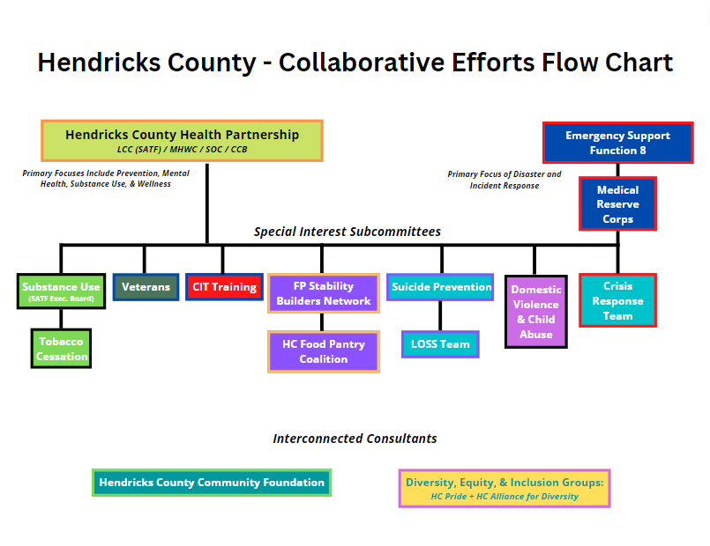

- Monthly HCHP Newsletter – Be sure to send any agency updates, upcoming events, news, etc. to Michael Aviah to be put into the Newsletter.

- Hendricks County behavioral health survey and strategic plan: The new survey has been completed but is not yet published. More information will be shared at our December Meeting. This survey will influence the goals we work on as a partnership over the next few years.

- Next Meeting: December 14th, 8:30am at MADE@Plainfield – In-Person End of Year Breakfast & 2023 Planning

- 2023 Proposed Calendar:
  - January 11th, 2023 – 8:30am-10:00am – Quarterly Professional Development Workshop – VIRTUAL
  - February 8th, 2023 – 8:30am-9:30am – Regular Meeting (+ LCC Grant Month) – HYBRID
  - March 8th, 2023 – 8:30am-9:30am – Regular Meeting – VIRTUAL
  - April 12th, 2023 – 8:30am-10:00am – Quarterly Professional Development Workshop – VIRTUAL
  - May 10th, 2023 – 8:30am-9:30am – Regular Meeting – VIRTUAL
  - June 14th, 2023 -- 8:30am-9:30am – Regular Meeting – VIRTUAL
  - July 12th, 2023 – 8:30am-10:00am – Quarterly Professional Development Workshop – VIRTUAL
  - August 9th, 2023 – 8:30am-9:30am – Regular Meeting – VIRTUAL
  - September 13th, 2023 – 8:30am – Regular Meeting – VIRTUAL
  - October 4th, 2023 – 8:30am-9:30am – Regular Meeting (+LCC Grant Month) – HYBRID
  - November 8th, 2023 – 8:30am-9:30am – End of Year Celebration Breakfast – IN-PERSON
  - December 13th, 2023 – 8:30am-9:30am – 2024 Planning & Strategy – VIRTUAL

- Proposed ‘Regular’ Meeting Structure going forward:
  - 5 min – Brief Introduction & Reminder of Mission/Purpose
  - 20 min – Assessment & Planning
    - What are the most pressing needs in our community related to our mission/purpose this month/season?
    - What gaps or barriers exist to meeting these needs in an effective way?
    - What systems need to be addressed from an “upstream” perspective to prevent these needs from being needs in the first place?
    - Is there any local, State, or Federal legislation that will affect our community in regards to our goals?
  - 25 min – Organizing & Volunteering
    - What are we going to do about it? What concrete steps (small/medium/large) can we take to make some progress on addressing these issues in the next month?
    - Review written and write any new guiding goals for the entity.
    - Who is volunteering to complete these steps?
    - Which key stakeholders aren’t at the table today that should be invited to the table next month?
  - 5 min – Special Interest Subcommittee Highlight Moment
  - 5 min – Concluding Thoughts, Action Step Commitments Review, Reminders for Next Meeting

Christa will update grant form and it will be sent out to new distribution list with updated Bylaws and Conflict of Interest form. Please complete your COI Form by January 1st 2023.

Financial Report/Budget Summary
Current balance of account (as of 10/31/22): $146,082
Expenses for October: $19,647 Deposits for October: $9258
Budget for 2022 is $32,200 per category (128,800 total)

Balances for Categories:
Discretionary funds $5000
Education/Prevention $7584
Treatment/Intervention $0
Law Enforcement/Criminal Justice $7195

SATF Executive Board / Substance Use Special Interest Committee

Diane Buxton, Chase Cotten, Jeremy Watson, Christina Anderson, Rosie Fakes, Betsy Schuler, Chuck Parsons, Christa Detzel. No follow up discussion today – no actions taken.

Adjourned: 9:25
NEXT MEETING
December 14, 2022 – In person, MADE@Plainfield, 8:30am

